**Oracle 11g rac安装**

只有私网IP和公网IP需要手动配置网卡，其他由rac自动加

SSH互信在11g开始可以在页面配置

先绑定磁盘，再创建asm盘

**参考官方文档：**

[https://www.oracle.com/technetwork/cn/articles/hunter-rac11gr2-iscsi-083834-zhs.html#4](https://www.oracle.com/technetwork/cn/articles/hunter-rac11gr2-iscsi-083834-zhs.html" \l "4)

<https://www.cnblogs.com/leohahah/p/9488963.html>

1. **共享存储配置**

**1、下载openfiler，安装完成后，添加一块70G的磁盘/dev/sdb**

1. **创建data、fra、ocr三个Volume并map**

登录openfiler web页面，用户名密码是openfiler/password

点击create new physical volumes后点击/dev/sdb

点击页面右下角Reset，然后点击Create。分区类型为Physical volume

点击Volume Groups

输入名称rac-db，勾选复选框，单击Add volume group

点击输入内容，设置大小，卷类型选择block（iSCSI，FC，etc）

点击Services标签栏设置iSCSI Target 为Enable 开启服务Start

返回Volumes标签页，点击Add Volume，然后点击iSCSI Targets，选择LUN Mapping标签 点击Map

**参考《使用OpenFiler来模拟存储配置RAC中ASM共享盘及多路径（multipath）的测试.docx》**

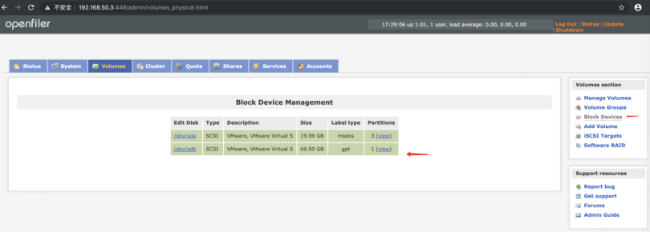

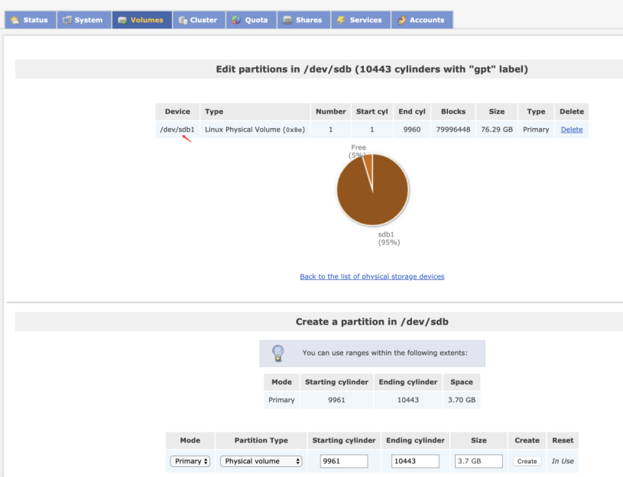

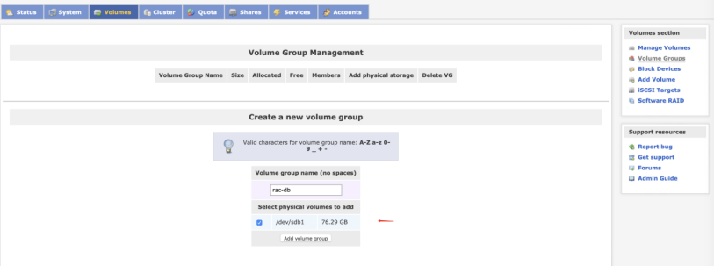

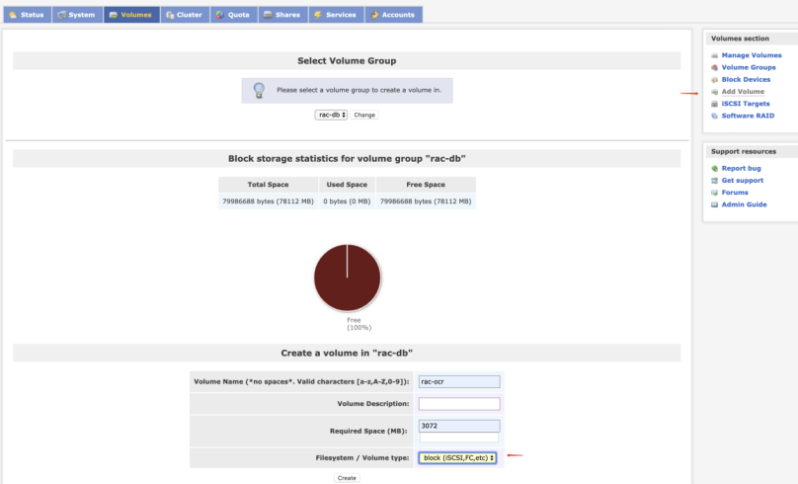

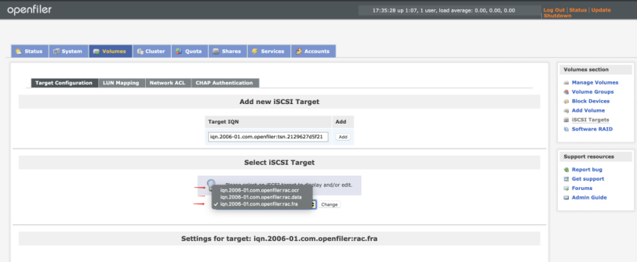

1. **在节点1和节点2执行init.sh、yum.sh完成后，配置静态IP，关闭防火墙，安装iscsi客户端，**

[root@rac2 Desktop]# service iptables stop

[root@rac2 Desktop]# chkconfig iptables off

修改/etc/selinux/conf,disabled

[root@rac2 Desktop]# **yum install iscsi-initiator-utils**

[root@rac2 Desktop]# **service iscsid start**

[root@rac2 Desktop]# **chkconfig iscsid on**

[root@rac2 Desktop]# **iscsiadm -m discovery -t st -p 192.168.50.3**

Starting iscsid: [ OK ]

192.168.50.3:3260,1 iqn.2006-01.com.openfiler:rac.fra

192.168.50.3:3260,1 iqn.2006-01.com.openfiler:rac.data

192.168.50.3:3260,1 iqn.2006-01.com.openfiler:rac.ocr

**4、设置开机自动连接ISCSI远程磁盘**

iscsiadm -m node -T iqn.2006-01.com.openfiler:rac.fra -p 192.168.50.3 --op update -n node.startup -v automatic

iscsiadm -m node -T iqn.2006-01.com.openfiler:rac.data -p 192.168.50.3 --op update -n node.startup -v automatic

iscsiadm -m node -T iqn.2006-01.com.openfiler:rac.ocr -p 192.168.50.3 --op update -n node.startup -v automatic

[root@rac2 Desktop]# start_udev

Starting udev: [ OK ]

参考：[https://www.oracle.com/technetwork/cn/articles/hunter-rac11gr2-iscsi-083834-zhs.html#4](https://www.oracle.com/technetwork/cn/articles/hunter-rac11gr2-iscsi-083834-zhs.html" \l "4)

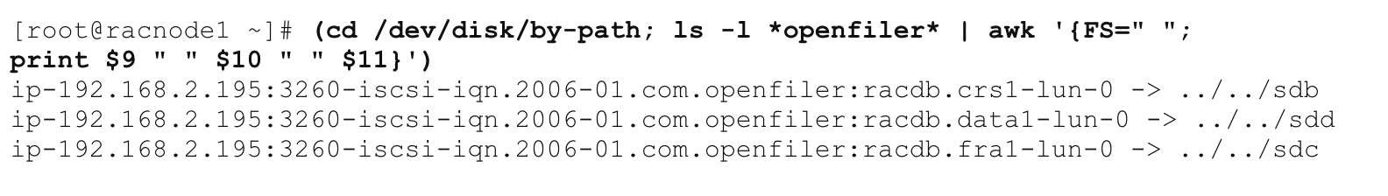

**5、磁盘绑定udev**

[root@rac1 Desktop]# **cat test.sh**

for i in d c e

do

echo "KERNEL==\"sd*\", BUS==\"scsi\", PROGRAM==\"/sbin/scsi_id --whitelisted --replace-whitespace --device=/dev/\$name\", RESULT==\"`/sbin/scsi_id --whitelisted --replace-whitespace --device=/dev/sd$i`\", NAME=\"asm-disk$i\", OWNER=\"grid\", GROUP=\"asmadmin\", MODE=\"0660\"" >> /etc/udev/rules.d/99-oracle-asmdevices.rules

done

[root@rac1 Desktop]# **./test.sh**

**6、配置rac的public IP、VIP、Private IP、ScanIP**

[root@rac1 Desktop]# **cat /etc/hosts**

127.0.0.1 localhost localhost.localdomain localhost4 localhost4.localdomain4

::1 localhost localhost.localdomain localhost6 localhost6.localdomain6

#Public IP

192.168.50.1 rac1

192.168.50.2 rac2

#VIP

192.168.50.10 rac1-vip

192.168.50.20 rac2-vip

#Private IP

1.1.1.1 rac1-priv

1.1.1.2 rac2-priv

#Scan IP

192.168.50.4 scanip

1. **安装grid**

cd /u01/grid/rpm/

rpm -ivh cvuqdisk-1.0.9-1.rpm

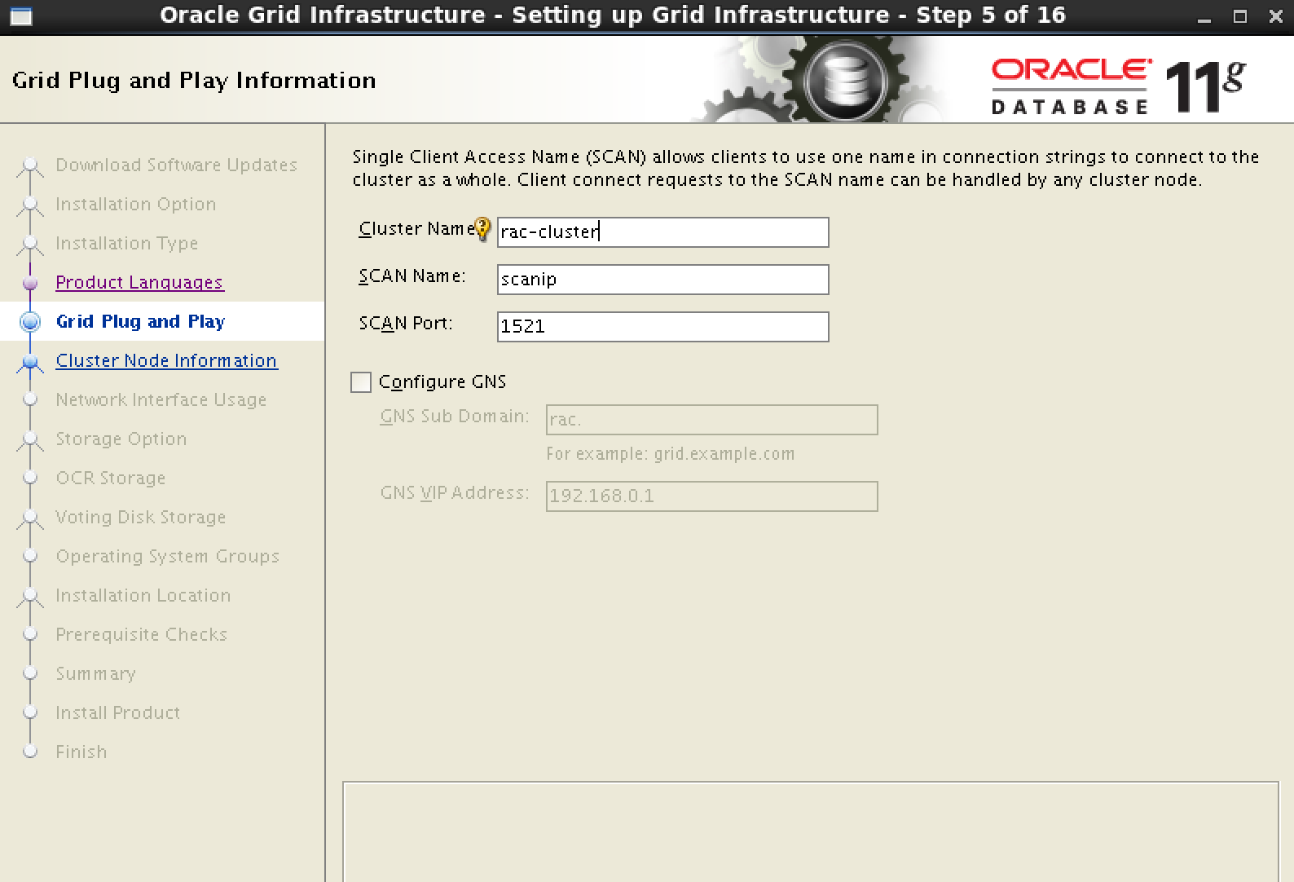

ssh在界面配置。可以不用命令行配。

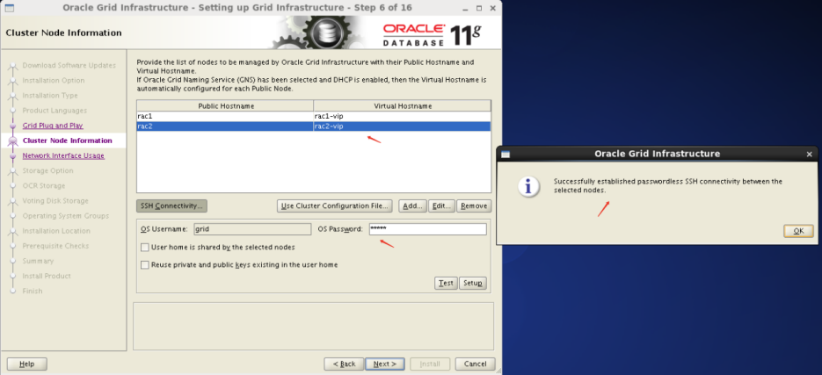

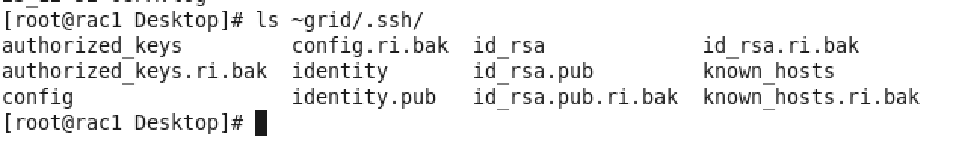

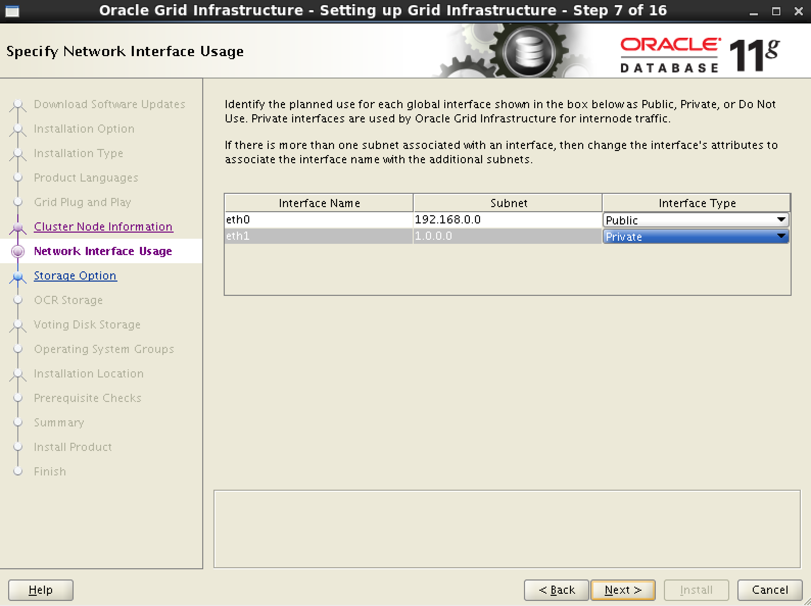

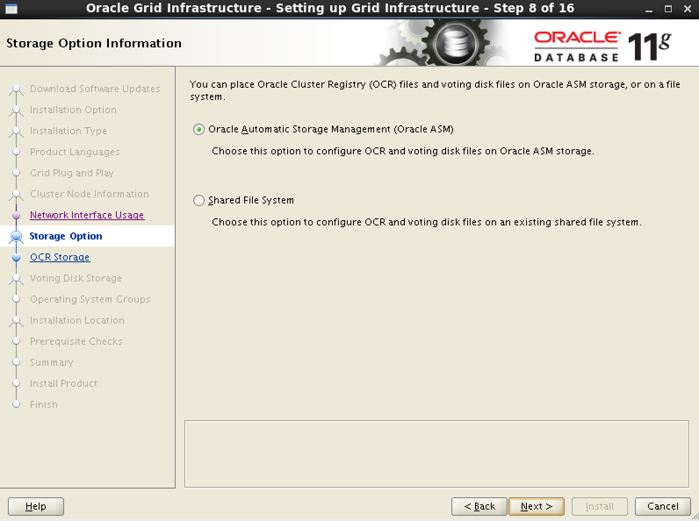

安装三个oracle asm的依赖包

rpm -ivh

kmod-oracleasm-2.0.8-16.el6_10.x86_64.rpm

oracleasmlib-2.0.4-1.el6.x86_64.rpm

oracleasm-support-2.1.8-1.el6.x86_64.rpm

配置asm

[root@rac1 Desktop]# service oracleasm configure

Default user to own the driver interface []: grid

Default group to own the driver interface []: asmadmin

Start Oracle ASM library driver on boot (y/n) [n]: y

Scan for Oracle ASM disks on boot (y/n) [y]: y

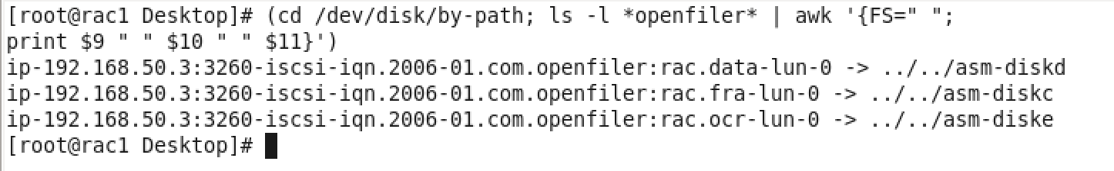

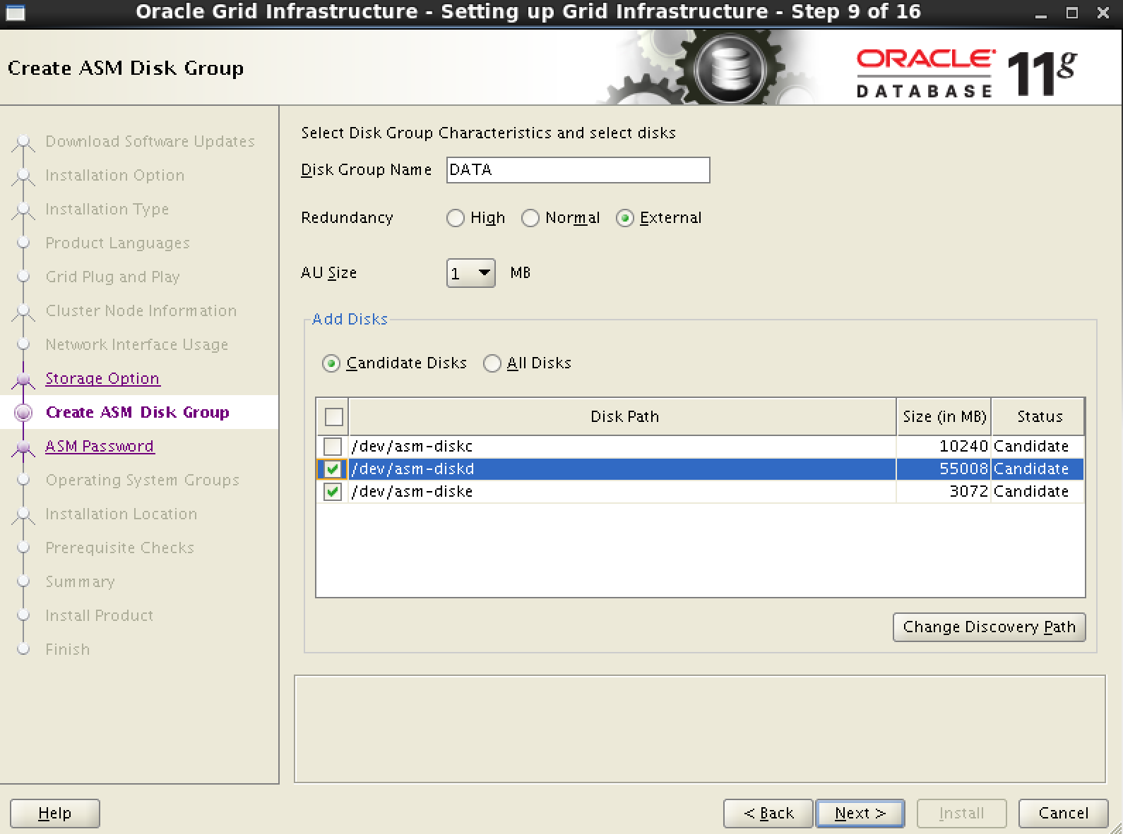

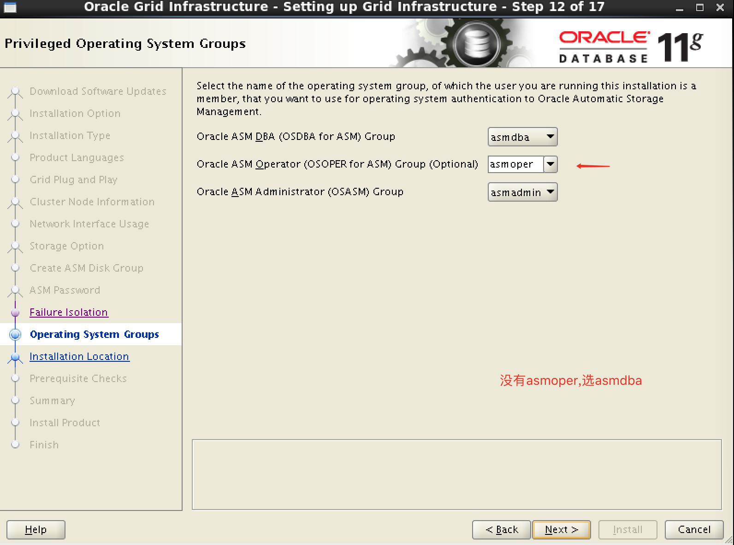

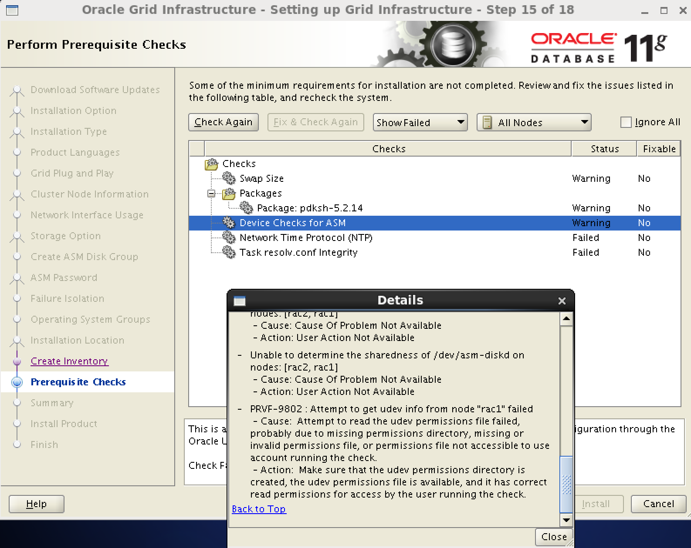

这个问题直接忽略，不影响，暂不清楚原因。

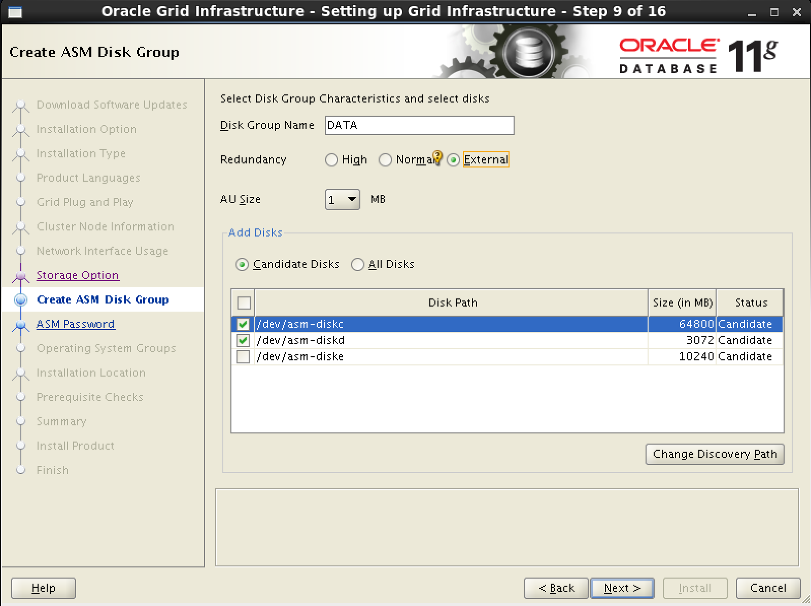

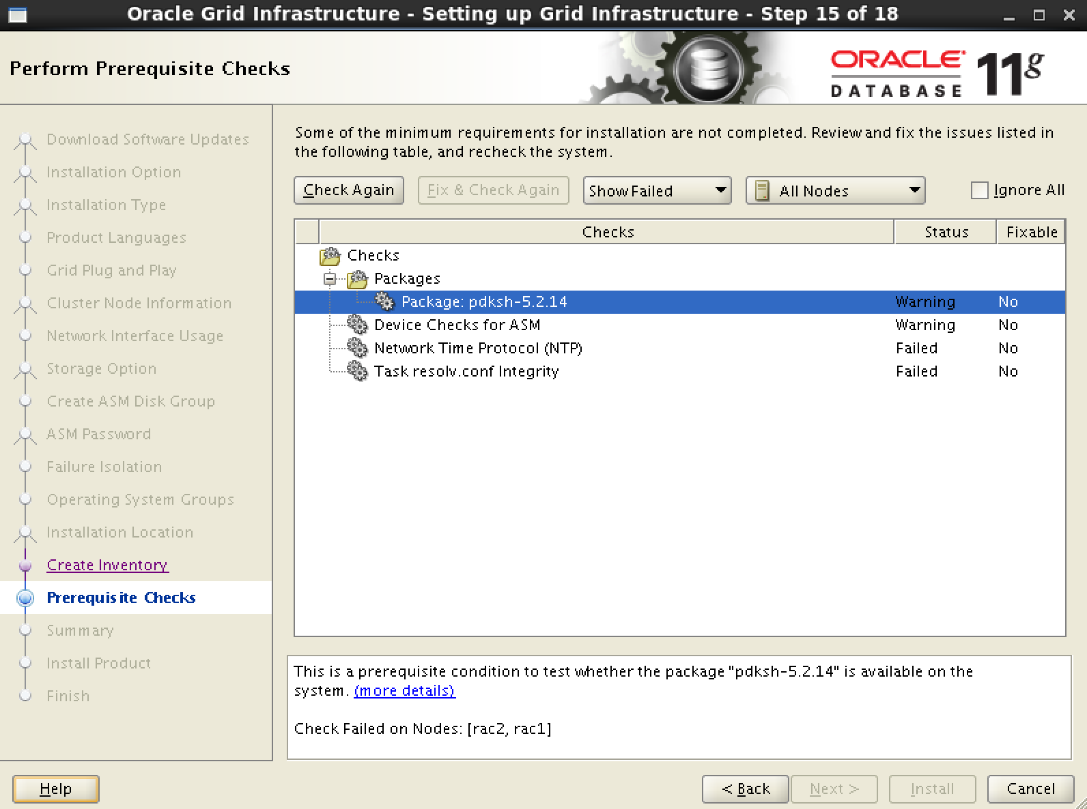

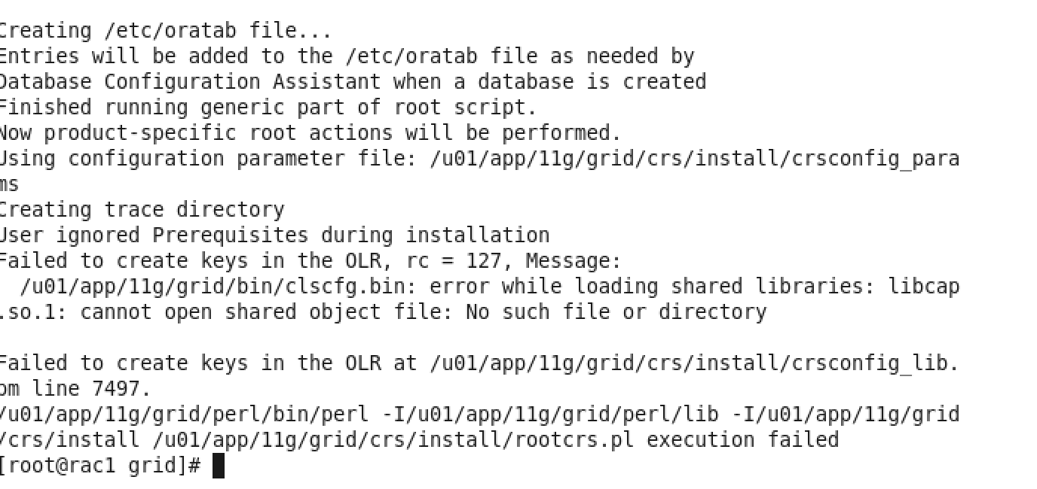

[root@rac1 grid]# yum install compat-libcap1

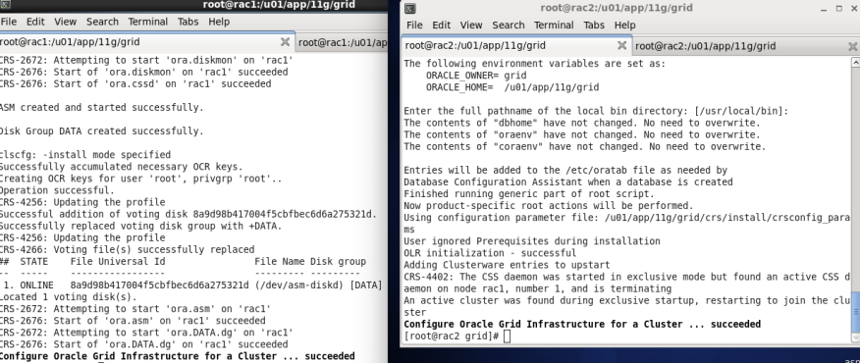

机器重启，过一会，全部资源就会启动起来

[root@rac2 Desktop]# source ~grid/.bash_profile

[root@rac2 Desktop]# crsctl check crs

CRS-4638: Oracle High Availability Services is online

CRS-4535: Cannot communicate with Cluster Ready Services

CRS-4529: Cluster Synchronization Services is online

CRS-4534: Cannot communicate with Event Manager

1. **安装oracle**

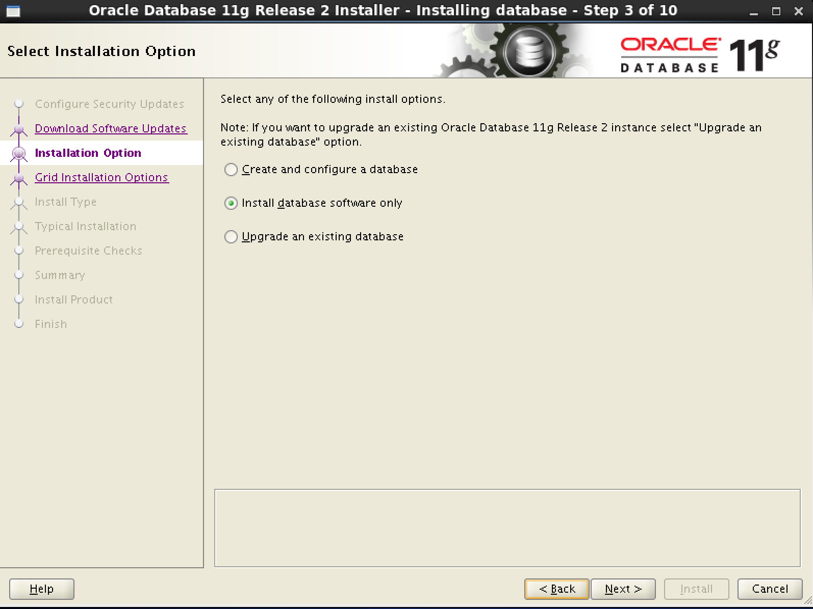

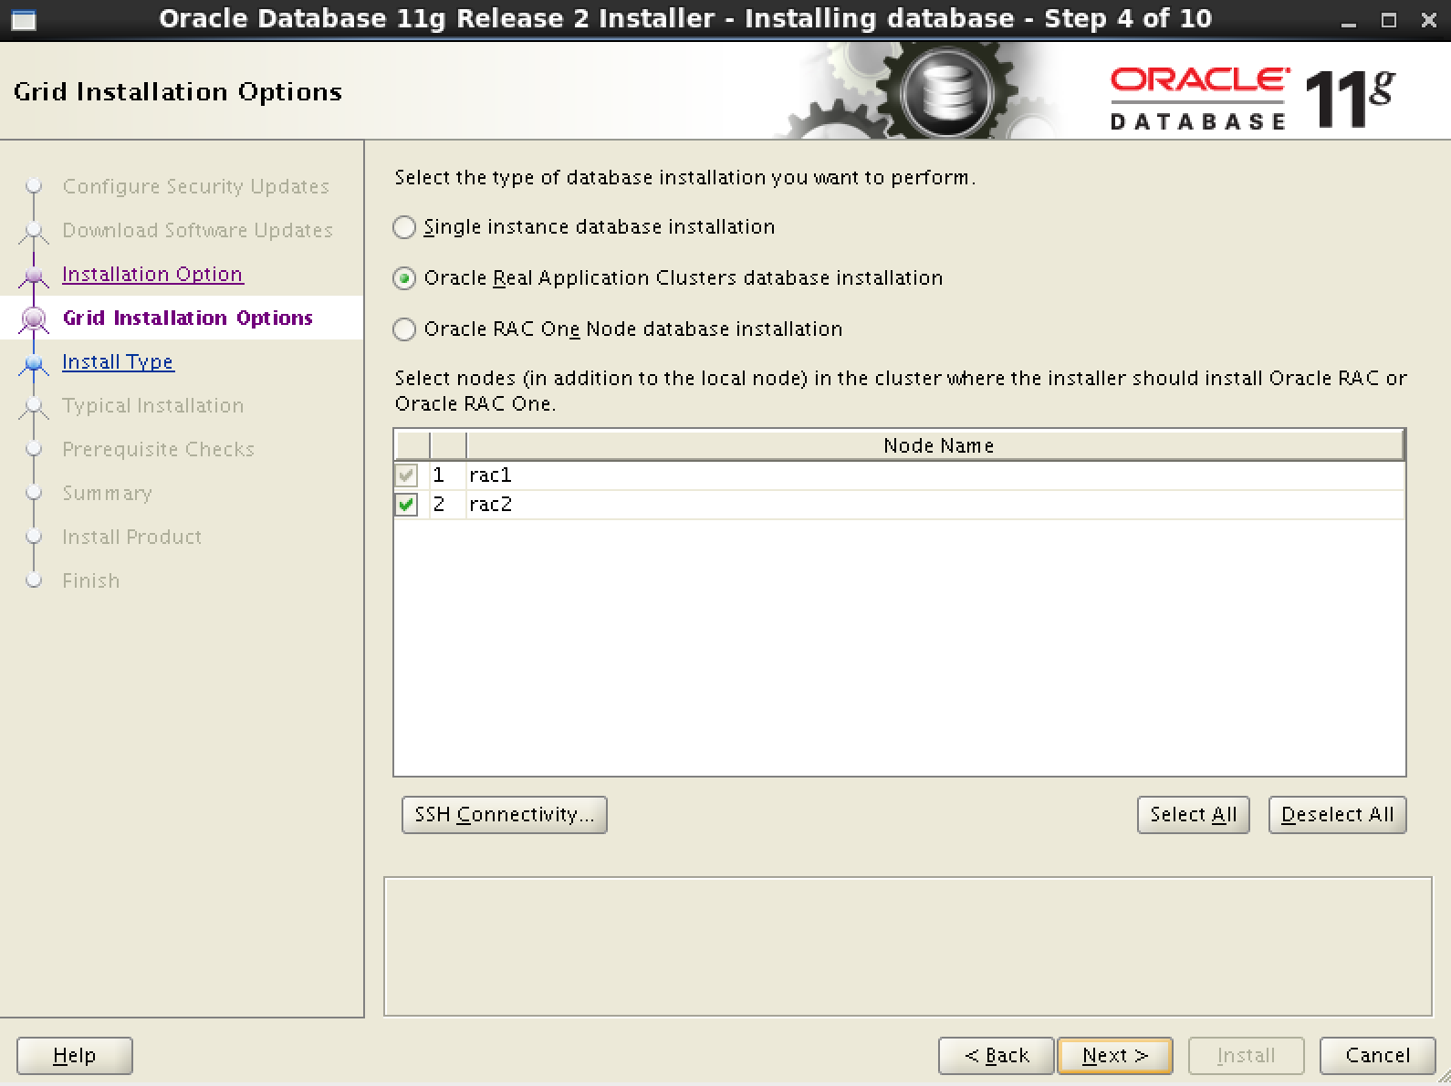

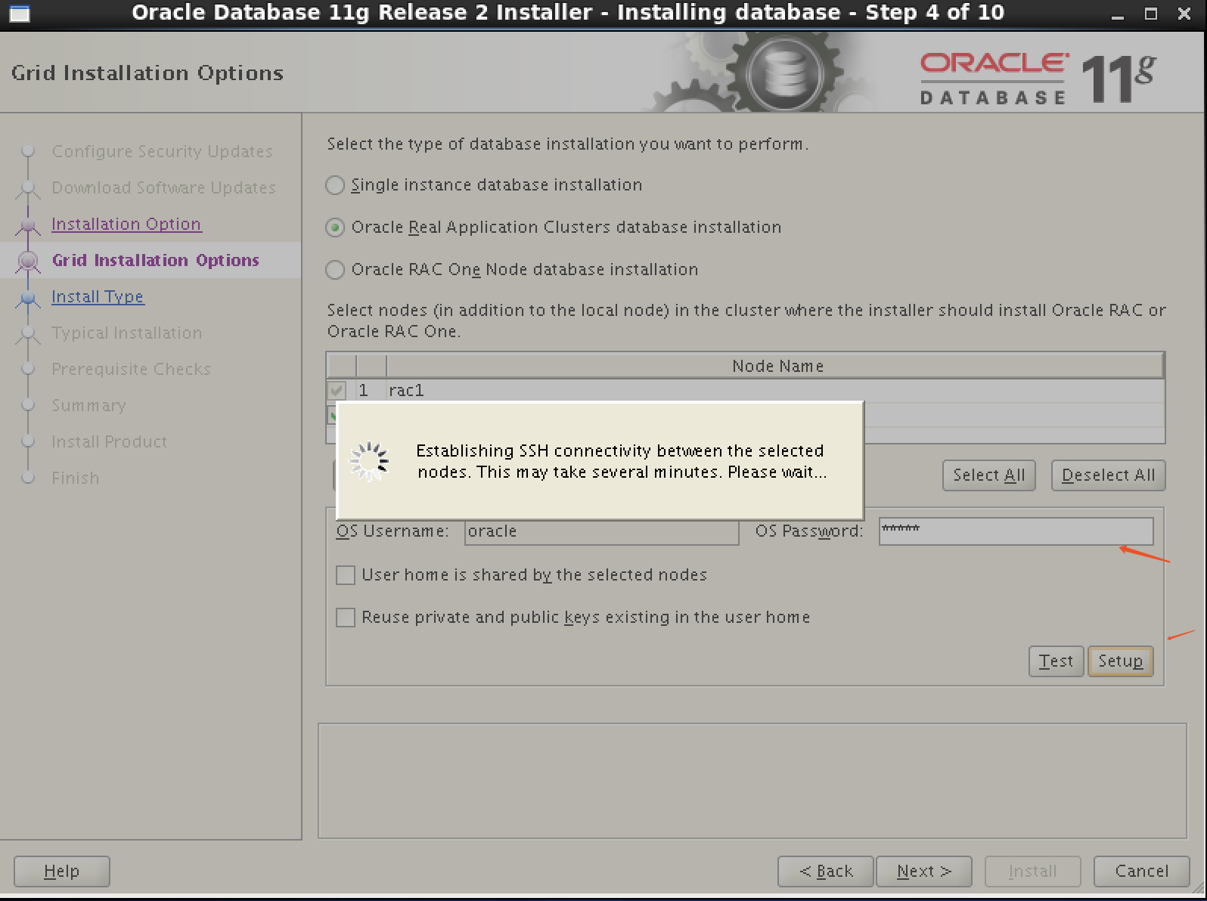

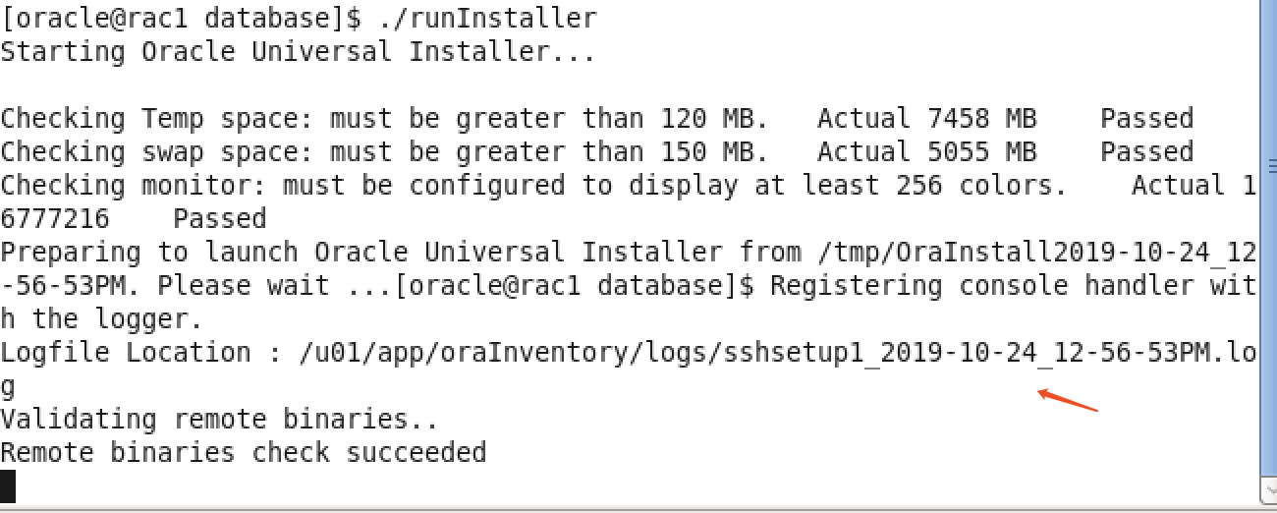

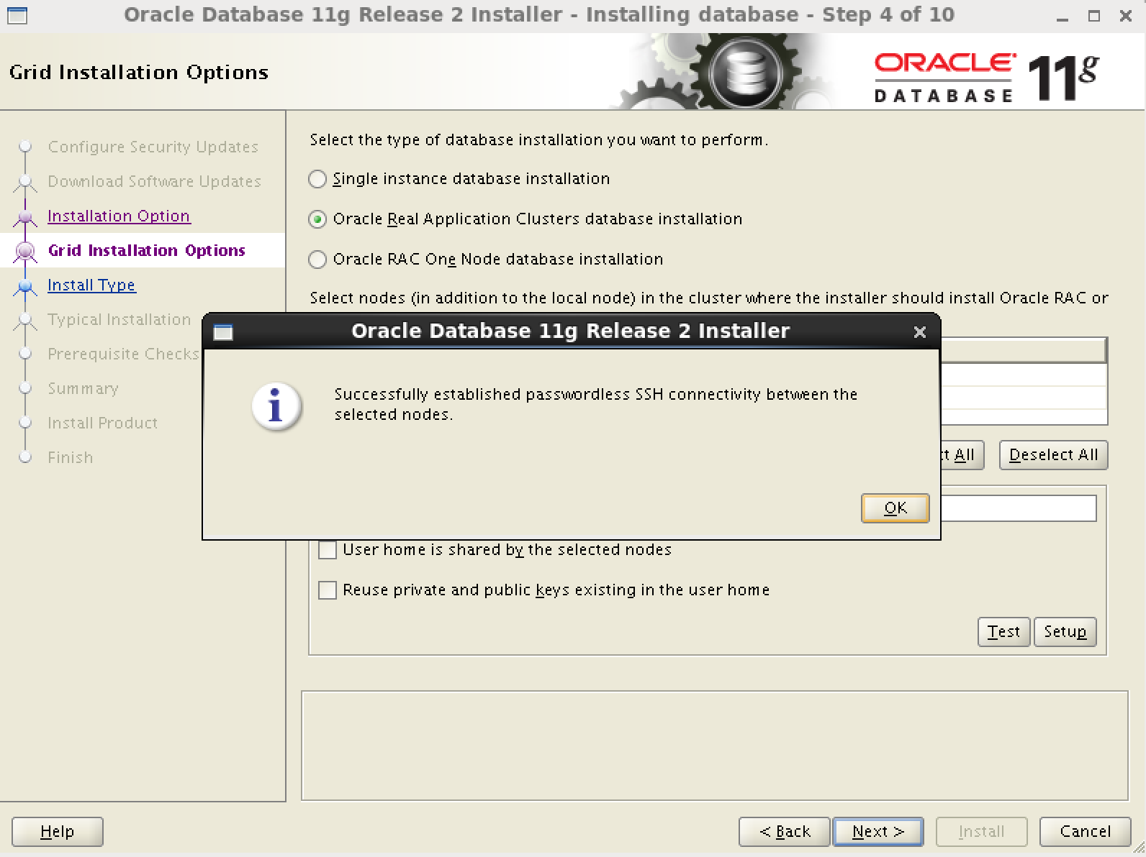

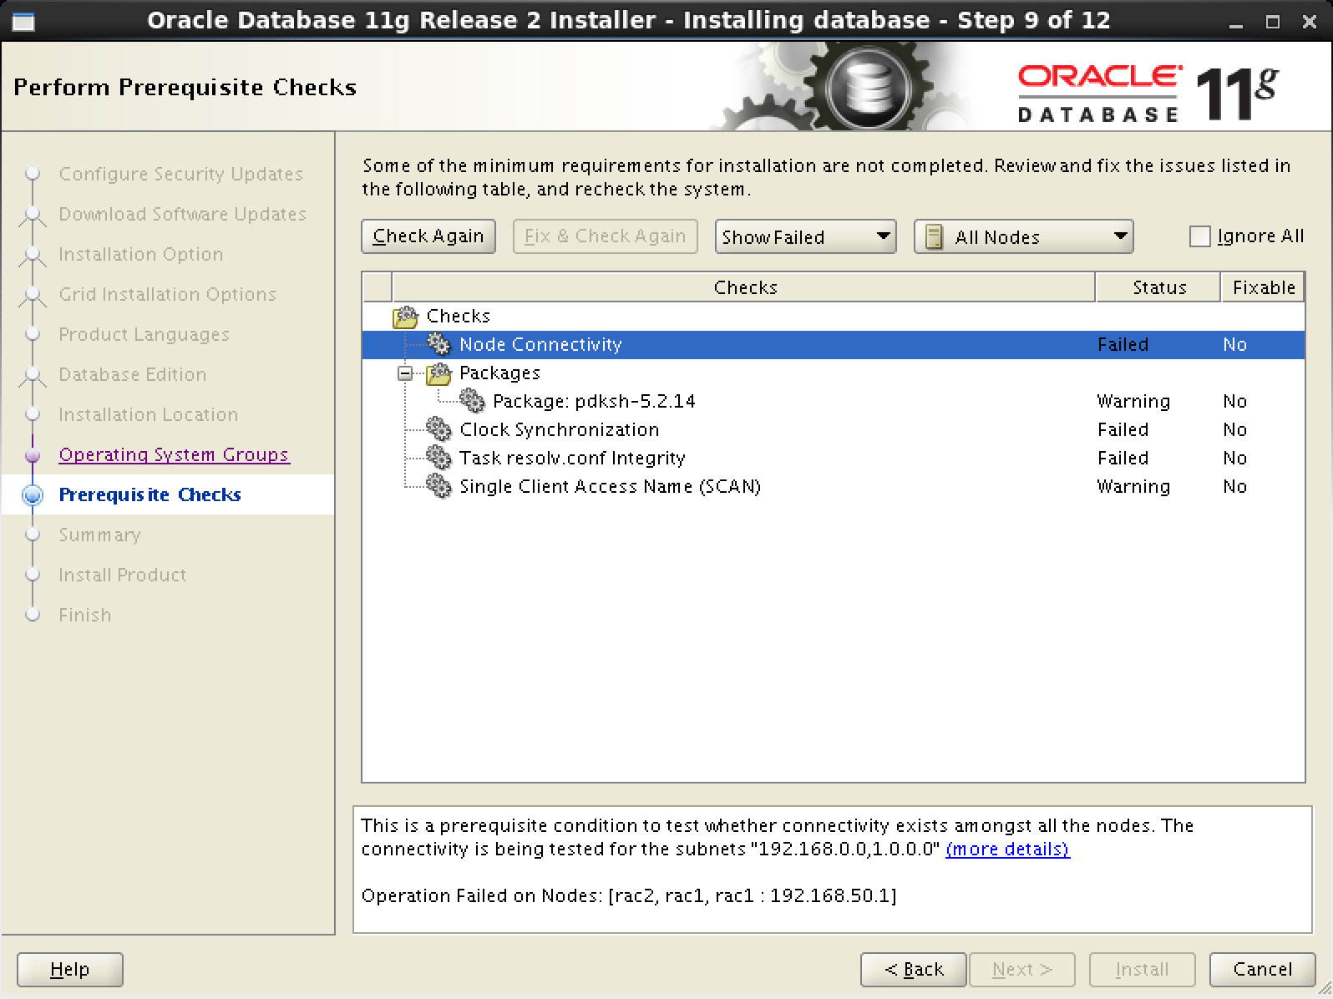

修改/etc/selinux/conf,disabled，重启机器，没有该报错

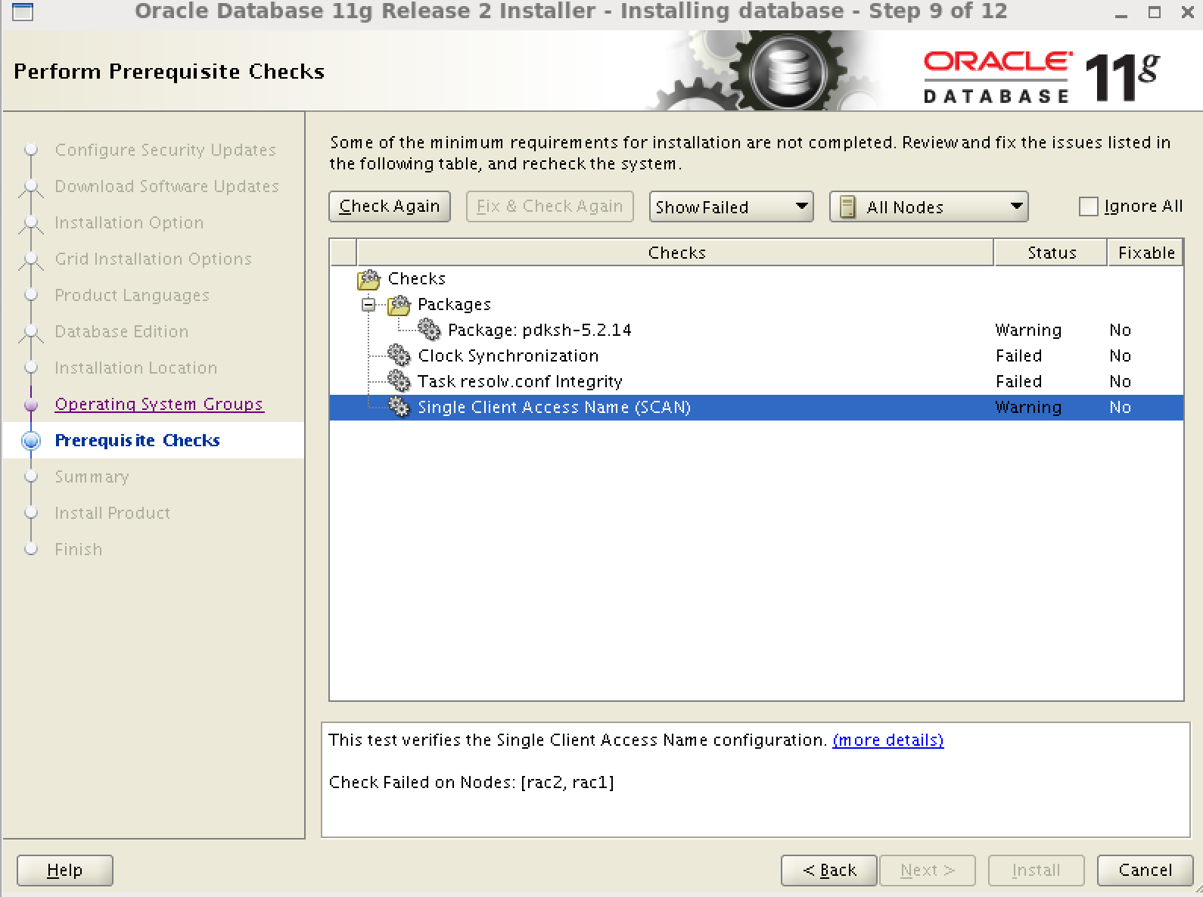

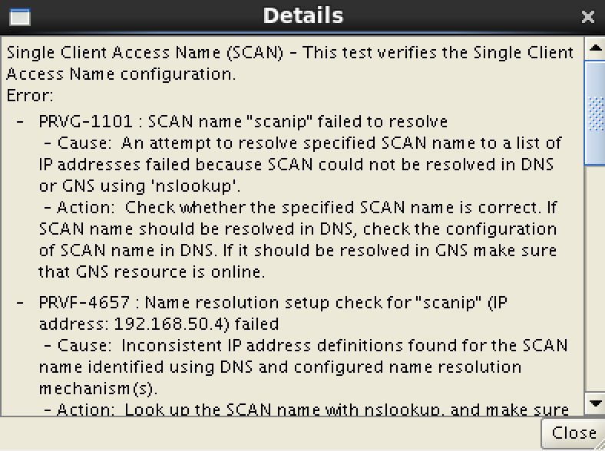

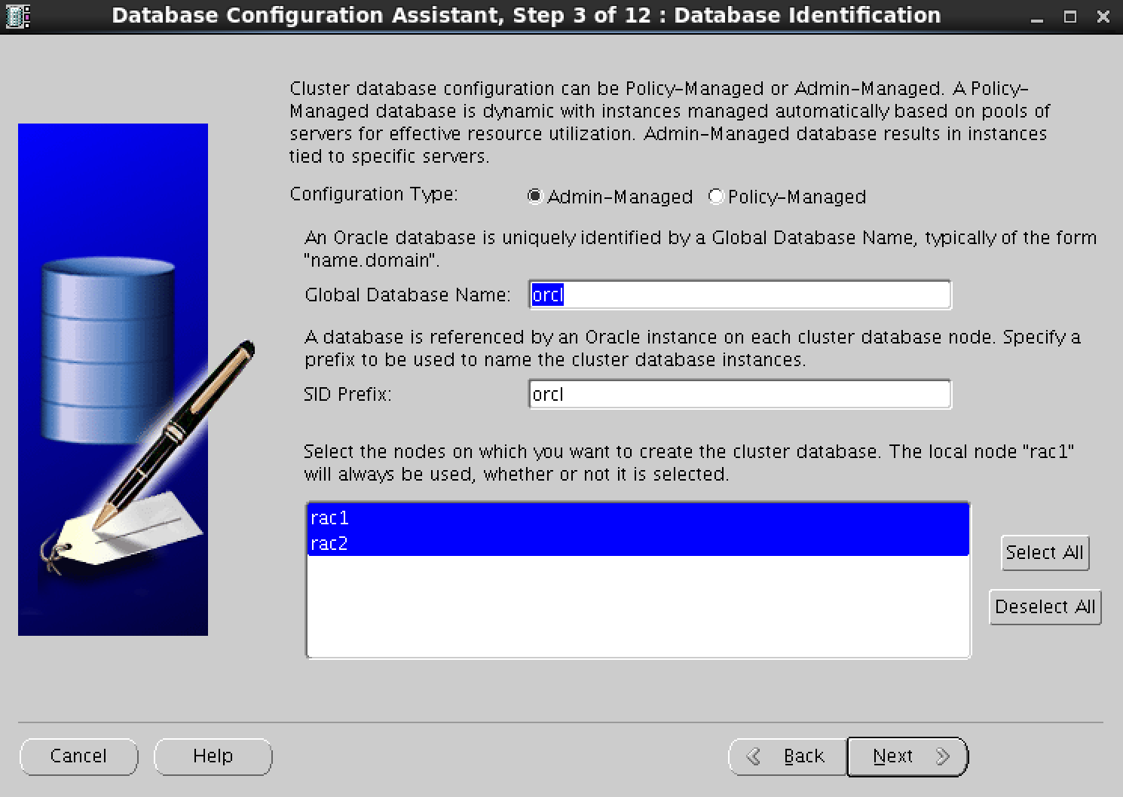

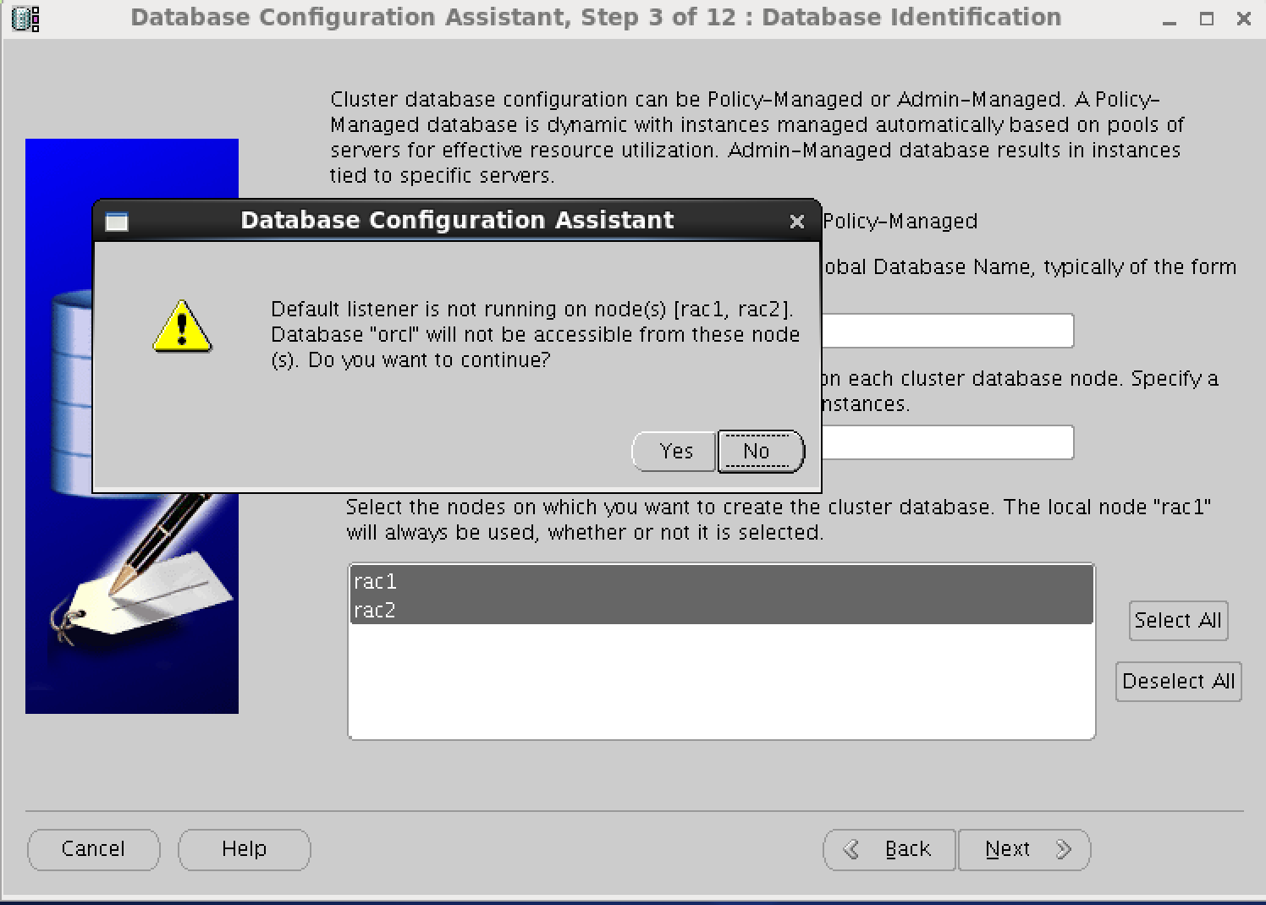

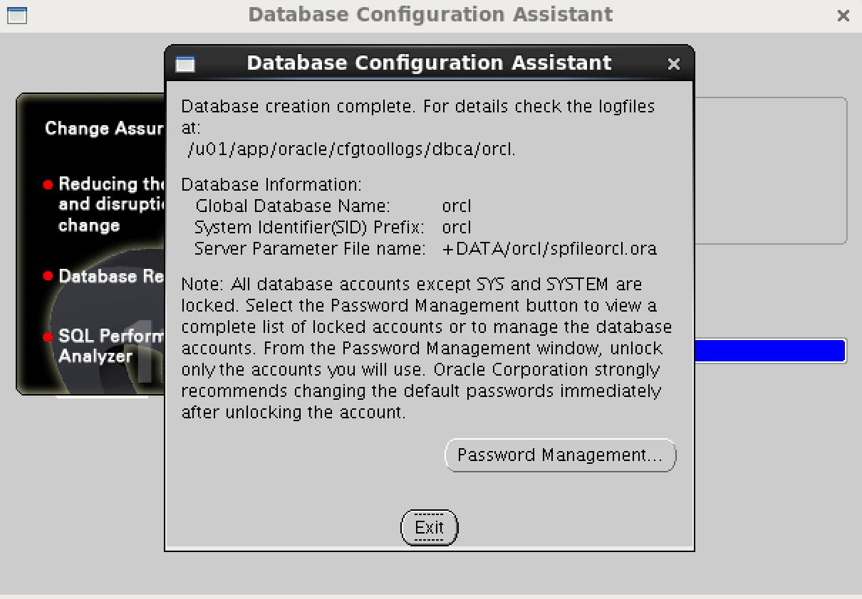

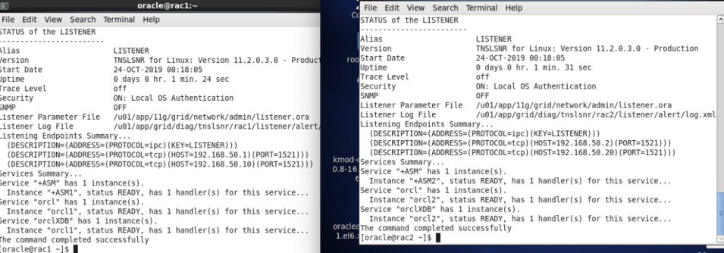

遇到的问题：



这个问题直接忽略，不影响，暂不清楚原因。

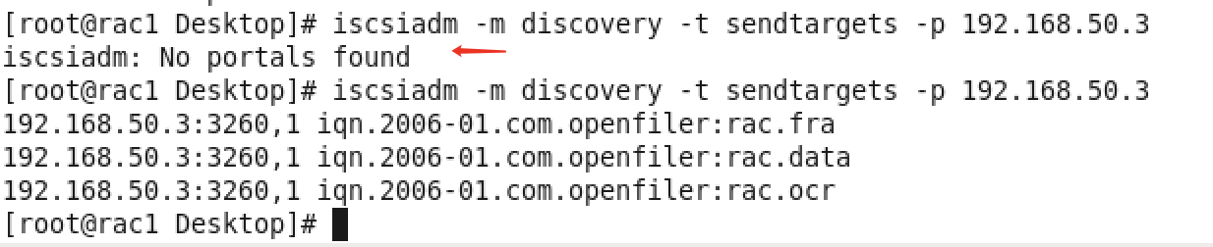

注释/etc/initiators.deny里面的内容

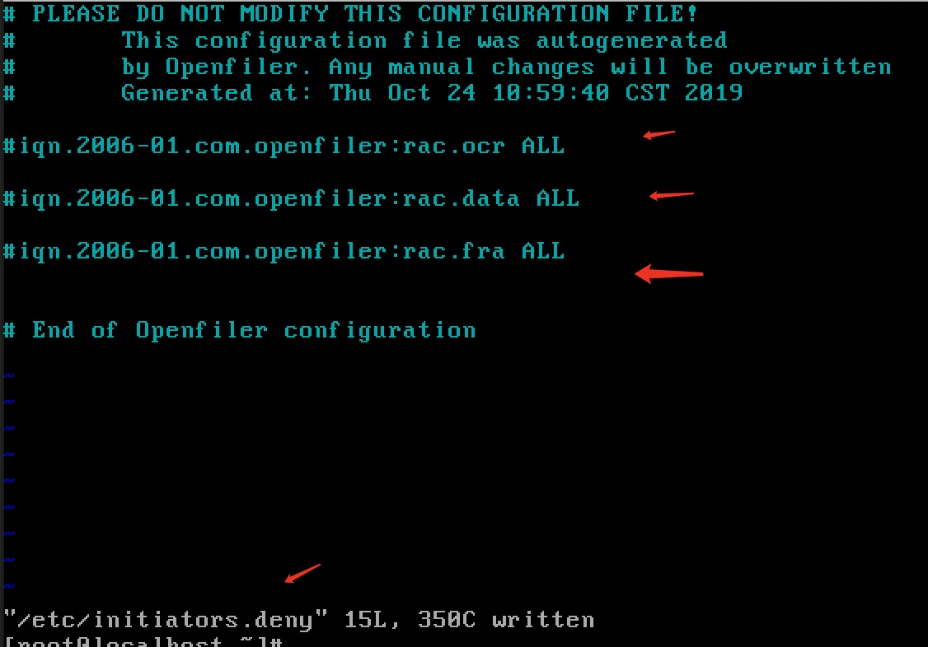



修改/etc/selinux/conf,disabled，重启机器，没有该报错